Information for Teachers

**of students who are deaf or hard of hearing**

[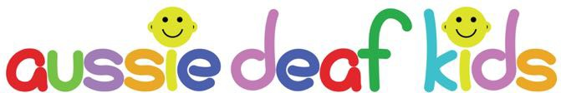](https://www.aussiedeafkids.org.au/)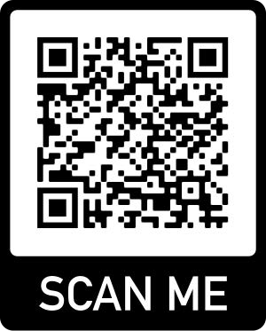

**Contents:**

1. Personal information
2. Hearing information
3. Device information
4. Assistive devices in classrooms
5. Classroom adjustments
6. Sharing information with teachers and fellow students
7. Classroom acoustics
8. Listening fatigue
9. Managing listening fatigue
10. Making school productions deaf-friendly
11. School sports for D/HH students
12. Transition to post-school education and employment
13. Useful website links



## Personal Information

Insert child's image here if desired

Child's name:

Date of Birth:

Parent/carer names:

Contact details:

## Hearing Information for

Enter child's name here

[Type and degree of hearing loss (click for help)](https://www.aussiedeafkids.org.au/types-of-hearing-loss.html#03):

For example: Bilateral sensorineural moderate to severe loss

What this means:

For example: Right ear better so position in class is important

Other medical considerations:

For example: LVAS so avoid knocks to head

How I communicate:

Technology used:

For example: Auslan, spoken language or other communication methods

For example: Hearing aids, cochlear implants, remote microphone/FM or other technology used

Supports received outside of school:

For example: Speech therapy or OT

## Device Information for

Enter child's name here

Brief instructions for

Enter device name here

Insert or type operational instructions

Insert device image here

Insert device image here

Brief instructions for

Enter device name here

Insert or type operational instructions

# Assistive Devices in the Classroom

Several technological devices can assist a child's learning in the classroom. Their use and benefits will depend on the child's level of hearing loss, the type of hearing aid or cochlear implant they wear, and the child's age.

|  |
| --- |
| **REMOTE MICROPHONE TECHNOLOGY or FM SYSTEMS**  These devices usually consist of a microphone (transmitter) and a receiver. The receiver is either attached to the child's hearing aid or cochlear implant or worn around their neck. The microphone transmits sound wirelessly to the receiver, providing improved speech perception in noisy environments. There are various FM (frequency modulated) units that the teacher can use and handheld microphones that other students can pass around. |
| **STREAMERS and SOUND FIELD SYSTEMS**  Streamers are designed to direct sound from devices such as televisions, computers, whiteboards and tablets to the child's hearing aid or cochlear implant. Sound field systems distribute sounds (such as a teacher’s voice) evenly and consistently throughout a classroom. The teacher uses a microphone that amplifies their voice via a loudspeaker installed in the classroom. |
| **INTERACTIVE WHITEBOARDS and LIVE CAPTIONS**  Interactive whiteboards provide students with hearing loss with visual resources, including captioning. Once a child can read proficiently, captioning is a technology that can enhance their learning. The use of captions or subtitles should be encouraged whenever a video is played in the classroom. |
| **MOBILE PHONES and APPS**  There are constantly new developments in mobile functionality that can assist with hearing. There are also speech to text apps that may be helpful to older students in the classroom. |

# Classroom Adjustments

Adjustments in the classroom can make a big difference to a child's learning. They are crucial in giving a child equal access to education.

However, adjustments need to be reasonable and not negatively impact other students or be unaffordable.

Adjustments should be negotiated between parents, the school and support staff each year or more often as needed. It is good to encourage the child's involvement in these meetings from an early age.

Here are some common adjustments...

* **Access to Auslan interpreters or note-takers.**
* **Use of assistive devices such as FM systems.**
* **Seating arrangements in the classroom.**
* **Adjustments to classrooms such as lighting, carpeting, installation of soundfield systems.**
* **Choosing to teach in quieter classrooms where possible.**
* **Use of captions for videos.**
* **Use of visual aids.**
* **Written handouts for information regarding assessments or homework.**
* **Teach and encourage other students to use some basic Auslan signs.**
* **Modifications required for assessments - extra time, rest breaks, interpreters, separate room.**
* **Provision of transcripts.**
* **Introduce a buddy system.**
* **Allow for lip reading by facing student, speaking clearly and not covering the mouth.**
* **Introduce new subject-specific words to students and Auslan interpreter before the lesson.**

# Sharing information with classmates and teachers



Encourage parents, support teachers or teachers of the deaf (TOD) to share information about a child with hearing loss. Teachers and students will be more knowledgeable and therefore more able to assist a student who is deaf or hard of hearing. Here are some ways information can be shared:

### Give a short presentation

This could be in person or on PowerPoint. Parents should explain what it means to have a hearing loss and the type of adjustments needed to maximise their child's learning. They could involve their child to help with demonstrations.

### Create an information sheet about the child

Ask the parents to create an information sheet about their child using the earlier information templates in this book. This is helpful for other teaching staff to refer to when in the classroom. Information should be concise and the use of images is recommended.

### Hold a Question & Answer session

This could be for either students or teachers or both. It is good for parents to have some pre-prepared questions and answers. If a parent is not comfortable conducting a Q&A they could ask the child's itinerant support teacher or TOD to host the session.

# Classroom Acoustics

Australia has acoustic standards and recommendations for primary school teaching spaces or single classrooms, but these are not legislated or regulated. The recommended Australian Standards for typically developing children are:

* + Unoccupied noise levels: < 35 dBA
  + Occupied sound levels of <50 dBA

There are a number of free apps available for iOS and Android phones to measure decibel levels.

Reducing the noise levels in the classroom will benefit teachers and other children. The school, teachers and parents should all work together to measure noise levels and find ways to optimise classroom acoustics.

### Possible solutions

* Place rugs or carpets in the room.
* Hang curtains or blinds in the windows.
* Hang soft materials such as felt or corkboard on
* the walls.
* Place tables at an angle around the room instead of in rows.
* Turn off noisy equipment when it is not in use.

# Listening Fatigue

Students with hearing loss exert more listening effort than their hearing peers when processing speech. Lip reading, interpreting expressions and filling in the gaps in conversations involve active concentration, often for extended periods, and this can cause significant fatigue. Fatigue can affect the child’s classroom performance, capacity to learn effectively, social relationships and quality of life.

Children with hearing loss have described feeling tired, drained, or exhausted after periods of concentrated listening. Increased listening effort can lead to cognitive fatigue, where the child is likely to have difficulty concentrating, become distractible and be less attentive. Cognitive fatigue, in turn, can lead to feelings of stress, tension and emotional difficulties.

### Recognising the signs of listening fatigue

There are physical, cognitive, and socio-emotional indicators of fatigue in children. The student may lose focus on the task at hand, stop participating in class, appear distracted, irritable, tired, or even rest their head on their desk.

They could complain of headaches, display anxiety or stress, or become emotional. Children and adolescents might be reluctant to participate in activities after school or join in social situations that require listening.

# Managing Listening Fatigue



There are strategies for managing listening-related fatigue that can be implemented in the school setting:

* Optimise the listening environment through acoustic treatments of the floor, ceiling, and walls in the classroom.
* Minimise background noise and provide good lighting in the classroom.
* Encourage students to wear their hearing devices consistently in the learning environment and use assistive technology where appropriate.
* Always provide captioned audio-visual content.
* Schedule teaching tasks that require substantial listening in the morning when the child is more likely to feel fresh and alert.
* Allow the student to have some quiet time or remove their listening devices for a time. Give the student a pass card, allowing them to leave the classroom discretely if they feel anxious or overwhelmed. They will need an allocated quiet and supervised place to go when they leave class.

Parents and teachers can assist students with hearing loss in developing self-advocacy skills to manage their own listening needs confidently.

# Making School Productions Deaf-Friendly

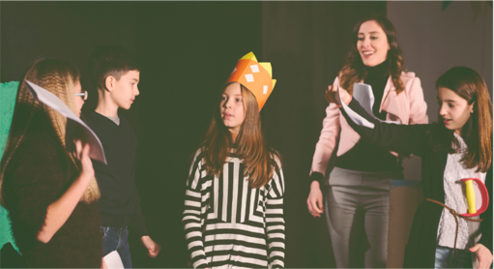The National Deaf Children's Society in the UK has some great tips for helping deaf children feel included and have an enjoyable experience participating in school plays. There are numerous tips about:

* giving instructions/direction
* managing cues
* costumes
* including deaf students
* lights out
* how technology can help.

For more information, see Useful Website Links.

# School Sports for D/HH Students

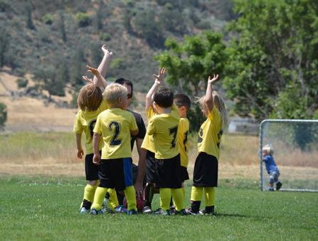**Adjustments for playing sport:**

* use visual aids, signals and physical demonstrations
* ensure player has understood instructions
* explain adjustments to teammates
* use lights, flags or arm raise to start a race
* allow player to tap referee to gain attention.

**School sporting opportunities:**

Deaf Sports Australia has various programs:

* Active Deaf Kids
* Deaf awareness training
* Sporting Schools Program.

There are also deaf sports days for school students – currently only in Victoria.

# Transition to post-school education and employment



Young people who are deaf or hard of hearing (D/HH) need transition planning and career guidance that addresses deafness-related issues. Building knowledge and skills will give them the confidence to overcome the barriers they may encounter in training, at TAFE or university, and work. The following transition practices are recommended for secondary students who are D/HH:

* Career guidance from professionals knowledgeable about deafness-related issues
* Collaboration between teachers of the deaf, mainstream teachers and career counsellors on transition planning
* Preparation to identify and address potential difficulties in postsecondary education and employment
* Development of the student's’ awareness of appropriate accommodations and the legal requirements of postsecondary education and employers to provide these
* Help in accessing the increasing range of technical assistive devices and systems available
* Self-determination instruction, including self-advocacy, negotiation, and assertiveness skills
* Discussion of how and when to disclose their hearing loss, explain its effects and inform employers of necessary accommodations and solutions
* Work experience with follow-up discussion to maximise learning
* Family involvement and empowerment
* D/HH adult role models and mentoring programs
* Strong links with agencies offering employment services and other post-school services.

Families, teachers, careers personnel, and teachers of the deaf should work with the student who is D/HH to support them in this transition process.

# Useful Website Links

**Assistive devices**

* + https://[www.deafnessforum.org.au/children-assistive-listening-technology-at-school-and-home/](http://www.deafnessforum.org.au/children-assistive-listening-technology-at-school-and-home/)
  + https://[www.hearing.com.au/Hearing-loss/Children-young-adults](http://www.hearing.com.au/Hearing-loss/Children-young-adults)
  + [NDCS - radio-aids-streamers-and-soundfields](https://www.ndcs.org.uk/information-and-support/technology-for-deaf-children-and-young-people/technology-products/radio-aids-streamers-and-soundfields/)
  + https://[www.aussiedeafkids.org.au/assistive-listening-devices-2.html](http://www.aussiedeafkids.org.au/assistive-listening-devices-2.html)

**Classroom Adjustments**

* + https://[www.adcet.edu.au/students-with-disability/reasonable-adjustments-disability-specific/Deaf-Hard-of-Hearing](http://www.adcet.edu.au/students-with-disability/reasonable-adjustments-disability-specific/Deaf-Hard-of-Hearing)
  + https://[www.deafnessforum.org.au/factsheet-adjustments-for-students-with-a-hearing-impairment/](http://www.deafnessforum.org.au/factsheet-adjustments-for-students-with-a-hearing-impairment/)
  + <https://www.aussiedeafkids.org.au/classroom-tips.html>

**Classroom Acoustics**

* + <https://www.aussiedeafkids.org.au/courses/courses/classroom-engagement-of-children-who-are-deaf-or-hard-of-hearing-attending-mainstream-school/>
  + [NDCS - what-can-schools-do-to-improve-listening-conditions](https://www.ndcs.org.uk/information-and-support/being-deaf-friendly/information-for-professionals/creating-good-listening-conditions-for-education-settings/what-can-schools-do-to-improve-listening-conditions/)
  + [https://successforkidswithhearingloss.com/classroom-acoustics-impact-on-listening-and-learning/](https://successforkidswithhearingloss.com/classroom-acoustics-impact-on-listening-and-learning)

# Useful Website Links cont’d

**Listening Fatigue**

* + Listening-Related Fatigue in Children With Unilateral Hearing Loss - <https://doi.org/10.1044/2019_LSHSS-OCHL-19-0017>
  + Listening Can Be Exhausting —Fatigue in Adults and Children With Hearing Loss - <https://doi.org/10.1097/AUD.0000000000000099>
  + Listening-Related Fatigue in Children With Hearing Loss: Perspectives of Children, Parents, and School Professionals <https://doi.org/10.1044/2021_AJA-20-00216>
  + The Impact and Management of Listening-Related Fatigue in Children with Hearing Loss - <https://doi.org/10.1016/j.otc.2021.07.001>
  + Vanderbilt Fatigue Scale-Child - [https://www.vumc.org/vfs/sites/default/files/public_files/VFS/VFS-C%208-18-2022.pdf](http://www.vumc.org/vfs/sites/default/files/public_files/VFS/VFS-C%208-18-2022.pdf)
  + Vanderbilt Fatigue Scale-Parent - https://[www.vumc.org/vfs/sites/default/files/public_files/VFS/VFS-P%208-18-2022.pdf](http://www.vumc.org/vfs/sites/default/files/public_files/VFS/VFS-P%208-18-2022.pdf)

**Making school productions deaf-friendly**

* + [https://www.ndcs.org.uk/information](http://www.ndcs.org.uk/information-and-support/education-and-learning/primary-years/make-school-plays-deaf-friendly/)-and-su[pport/education-an](http://www.ndcs.org.uk/information-and-support/education-and-learning/primary-years/make-school-plays-deaf-friendly/)d[-learning/primary-years/make-school-plays-deaf-friendly/](http://www.ndcs.org.uk/information-and-support/education-and-learning/primary-years/make-school-plays-deaf-friendly/)

**School sports for D/HH students**

* + [https://www.aussiedeafkids.org.au/sport.html](•%09https:/www.aussiedeafkids.org.au/sport.html)
  + [https://deafsports.org.au/home/sporting-schools-program/](https://deafsports.org.au/home/sporting-schools-program)
  + [https://deafsports.org.au/active-deaf-programs/](https://deafsports.org.au/active-deaf-programs)

# Useful Website Links cont’d

**Transition to post-school education and employment**

* + <https://www.deafeducation.vic.edu.au/Resource/fact-sheets/SuppAdolfactRP.pdf>
  + <https://www.adcet.edu.au/students-with-disability>
  + <https://www.aussiedeafkids.org.au/beyond-school.html>

**Other helpful links**

* + Raising confident teens – practical advice for teachers (Cochlear)

<https://mss-p-007-delivery.sitecorecontenthub.cloud/api/public/content/3dba3e5030534f8cb8d990a5b2a55838?v=76bf210c>

* + Hearing implants and the classroom (Med-el)

<https://www.medel.com/docs/default-source/support-downloads/24176ce_r2_0-educators-guidebr-web.pdf?sfvrsn=32f24b45_2>